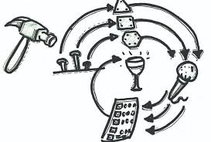

**Iteration/Sprint Documentation  
Iteration 4**

Mohit KHADGI, Dinesh BISTA, Sujata KOIRALA, Manish SHRESTHA, Anthony ATUCHETEAM 4

09/05/2020

Iteration/Sprint Documentation

**Theme & wish** **list:** In this sprint, we have assigned to improve customer satisfaction by reducing time to complete a task through webmasters and content contributions. Managing functions and keeping the content up to date is the key purpose. By adding Google Analytics, it helped us to track the types of visitors of the site. We maintain visually and progressively telling the story of the company’s services in a simple and easy-to-digest way. We also represent a confirmation that the contents are meaningful, engaging sites with easy-to-read content.

**Theme:** Improve Web typography as it is a branch of design and we need to master all its aspects. By adding and customizing distinctive letters, open forms, clear terminals, letterform contrast, body text size, leading, line length and colour contrast, and through valuable content, good organization, and attractive design.

**Wish list:** To focus on degree of usability by making it easy to read, navigate and understand. Some key usability elements such as simplicity, fast-loading pages, minimal scroll, consistent layout, and screen resolution are the factors to improve. The relative significanceof various content areas and elements are visually implied in many ways, ranging from typographic treatments, to image sizes and saturation, placement, etc.

Incoming Product Backlog

**US1:** As a user I want an emergency booking system so that they can provide services anytime. Completed

**US2:** As a staffing manager, I want to get an option for people to send resumes in website so that I can recruit new workers. Completed

**US3:** As an owner, I want to check the profit/loss of my company so that I can handle my business properly. Medium

**US4:** As a user, I want a membership option so that the price will be cheaper for regular customers. Completed

**US5:** As a user, I want contact details of a company in the website so that I can contact them whenever needed Completed

**US6:** As a user, I want to view map of a company on the website so that I can get the direction directly. Completed

**US7:** As a CEO of a company, I want to give access of security to a certain senior member so that there is less possibility of data breaches. Medium

**US8:** As an owner, I want to invest in best possible surveillance in the system so that I can protect my information. High

**US9:** As a user, I want my payment details to be private so that I can save my information. Sprint 4

**US10:** As a user, I want to have a website where I can hire staffs to be sent to work on different occasions as requested by our clients. Sprint 4

**US11:** As a staff management supervisor I the website to be accessible by the employees to view their overall ratings and feedbacks. Completed

**US12:** As a manager I want the website to have a login for staffs and employees. Completed

**US13:** As a manager I want the website to have a different login for our clients. Medium

**US14:** As a user, I want the website to be flexible so that I can select the works according to my interest and availability. Completed

**US15:** As a user I want to rate the employee that works for us according to the feedback of the customers so that he works with his full commitment. Sprint 4

**US16:** As a user I want to have the system which is easily adaptable according to requirement changes and suitable on any screen design.Completed

**US17:** As a user I want pre-booking system so that good services can be received. Sprint 4

**US18:** As a user I want to register to the system with my details, so that I do not have to provide my information every time. Completed

**US19:** As a user I want to login to the system so that I can get information regarding the services. Low

**US20:** As an owner I want to have the system which will track the success of the company along with planning according to different scenarios. Medium

**US21:** As a user I want to provide personal feedback so that company would also know about their competition in the market. Completed

**US22:** As a user, I want to have the system which will accept any payment options such as credit cards, debit cards, PayPal, etc. Medium

**US23:** As an owner I want to have the screen of the system to be simple and clear so that there will be no error while logging to the system. Sprint 4

**US24:** As an owner I want to know the details of every staff members and their backgrounds so that staff members can be distributed according to their levels. Low

**US25:** As a user, I want a proper website to book a service fast without any additional charges. Completed

**US26:** As a COE, I want to create a website to advertise the business creating ads and promotions. Low

**US27:** As a COE, I want to create a system to help workers to communicate via messages and emails letting them know about their job as soon as possible. Completed

**US28:** As a user, I want a fastest and guarantied service with convenient time schedule. High

**US29:** As a user, I want 24/7 costumer service so that I can contact the office anytime.Completed

**US30:** As an owner, I want my system to be protected and safe with limited access to the staff Medium

**US31:** As a user, I want to create an account in a system to save my information so that it will be easier for me to provide my details for multiple bookings. High

**US32:** As an owner, I want my provide access to staff just to record their attendance. Low

**US33:** As a user, I want to ensure that, I will get notification regarding the job. Also, I should be able to check it online what’s happening during the job. Completed

**Sprint Backlog**

|  |  |  |
| --- | --- | --- |
| **Requirement** | **Conditions of satisfaction** | **Task & Estimates** |
| **US9:** As a user, I want my payment details to be private so that I can save my information. | Login is required before  entering this page.  Payment accepted only through credit/debit card.  The pre-booking system only applies once the payment is accepted.  If payment is not accepted, an email will be sent immediately. | T1. Form of payment is created with the needed details as required. 1 day (Sujata)  T2. Security is ensured and card details are partially hidden for security reason. 1 day (Manish)  T3. Notification email once the payment is accepted.1 day (Dinesh) |
| **US10:** As a user, I want to have a website where I can hire staffs to be sent to work on different occasions as requested by our clients. | Staffs should be able to apply via email.  Once hired, they need to sign up with the company.  Staff will get job notifications and reply back if they are interested in any. | T4. An application form is to be created where users should also be allowed to attach resume. ½ day (Dinesh)  T5. A database should be created to store all the applications. 1 day (Mohit)  T6. A link should be created where staffs can make the available job reservation meeting their requirement. ½ day (Sujata) |
| **US15:** As a user I want to rate the employee that works for us according to the feedback of the customers so that he works with his full commitment. | Registration and Login is required.  Follow-up Email will be sent once a service has been provided where a user can give us the feedback via Email.  Also, there is a feedback option exist on the bottom of the website.  After the user gives u a feedback and comments it will ask you to rate the employee. | T7. Develop the feedback or comment section on the bottom to make it easier for the user. ½ (Manish)  T8. User should be able to view the name of the employer so that they can rate them in terms of their service.1/2 (Sujata)  T9. Create a link which needs to be sent to the user after the service is provided where they can give the feedback. 1day (Mohit) |
| **US17:** As a user I want pre-booking system so that good services can be received. | Login and registration are required.  User should be able to book our services by scrolling down our homepage.  Name, contact details, and request time are compulsory.  User can book our services through email or phone | T10. Create a database where we can see the booking and save the details for future reference. ½ day (Manish)  T11. User should be able to quote a booking by filing the details from our page. 1 day (Mohit)  T12. Create a database where user can book our services via email or directly from phone. ½ day (Anthony) |
| **US23:** As an owner I want to have the screen of the system to be simple and clear so that there will be no error while logging to the system. | User Registration and login needed.  Dynamic and user friendly interface required.  Password recovery during user login required. | T13. Create a database for user login ½ day (Sujata)  T14. Design a system that is all platform friendly example; android, apple, windows etc  ½ day (Anthony)  T15. Create user login database that include error check and debugging. ½ day (Dinesh) |

**BURN DOWN CHART**

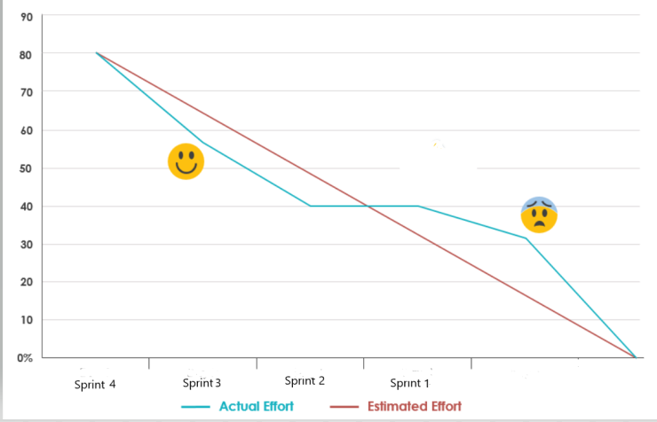

**Review Meeting:**

Sprint 4: Worked on design pictures, colour fonts and so on. Also, modified the contact page. Making all the available information easily visible to the user.

**Date and time**: 29/04/2020, 6:00 PM

**Venue**: Skype Video Call

**Minutes taken by**: Mohit, Sujata, Manish, Anthony, and Dinesh

**Agenda item 1: Demonstration feedback:**

* The website designing is attractive.
* Mostly necessary information is provided in the front page and easily visible to the user.
* If the user get confusion about our service, they can always do live chat with us as it is available 24/7.
* The contact details are highlighted as they can always ring us in any doubt during the trading hours.
* More work should be done on navigation.
* The service providers name should be visible to the clients so that they can rate them in person as well not only the company.

**Agenda item 2: Theme of next sprint**

The user wants to rate the service provider also not only the company. Also, they want a clear navigation in google map, so it will not waste their time for searching the address. We still need to make it better by working on it on time.

**Agenda item 3: Next review meeting**The next meeting is scheduled for 20/05/2020 at 1:00 pm

Retrospective Meeting:

**Date and time:** 10/05/2020 1:20pm

**Venue**: Video call on Facebook messenger

**Minutes taken by** Manish, Dinesh, Sujata, Mohit, Anthony

Item1: What went well?

* The overall outcome of the project was discussed in detail.
* All the further planning were made for the future project.
* The team members were able to address their issues and solve them significantly.
* The meeting was fruitful for our overall project.
* There was no interruption in internet connection throughout the meeting.

Item2: What could be improved?

* There should not be any delay in completion of any task.
* The meetings need to be carried out on a frequent basis.

Item3: What can we do?

* We can improve our documentation.
* We can improve the understanding between team members.
* We can introduce more ideas to our project.

Item4: What is not in our control?

* Failure of internet connection during the meeting.
* Corruption to one’s device.

Statement of Contribution:

Manish: Created a secured database to ensure that user’s privacy is protected during transactions. (1day)

Sujata: Created Database where staffs can make reservations for job according to their qualifications and job requirement. (½ day)

Mohit: Created a user feedback form, where staff reviews and ratings are done. (1day)

Anthony: Created a database where users can book for services by email or completing the forms online. (½ day)

Dinesh: Created a user login database that checks and corrects error. (½ day)